CENG 499 – Introduction to Machine Learning Spring 2017 – Homework 1
Part 4 Report
Onat Büyükakkuş – 2035772

To generate new input files according to 2016 and 2017 datas, I needed to calculate average of values. I used 5 columns: Open, High, Low, Close and Adj Close. I didn't take Volume attribute into my calculations because difference between 2016 and 2017 values of that attribute was so high.
For Analytical Solver part, first, I adapted my Analytical Solver source code to find w values from 2016 datas and calculate RMS Error from that w values and 2017 datas. After that, I created a loop, from 1 to 35, which indicates the window size. Then I created new .csv files for both 2016 and 2017 according to that window size (I uploaded two files named “part4-goog-2016.csv” and “part4-goog-2016.csv” with the minimum RMS Error.) and I ran the adapted Analytical Solver source code. For 34 different window sizes, I got the following datas and graph. (This data and graph are also visible at “part4-analyticalsolver-results.xlsx”)

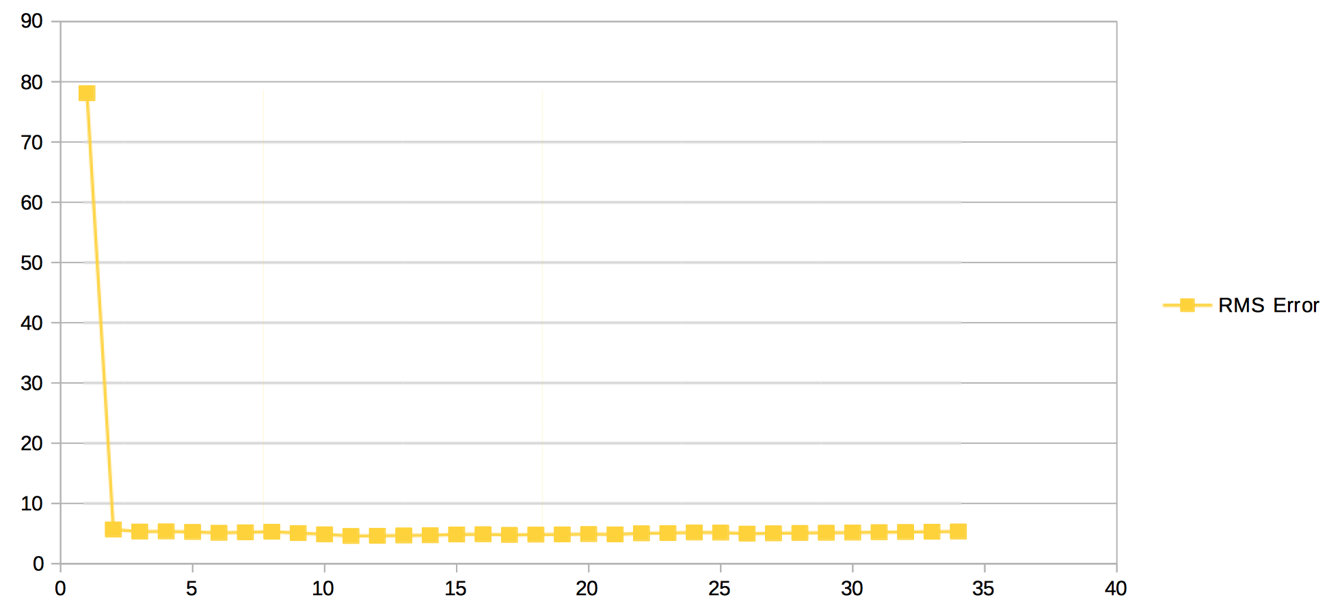
As it can be seen, best result i.e. minimum RMS error was (4.593) at when window size was equal to 11. So, I used 11 as window size for Iterative Solver and Weighted kNN Solver.
I ran my adapted Iterative Solver code with lambda = 0.0000001 and minimum change in RMS Error = 0.00001. I also uploaded results for this part as “part4-output-for-iterativesolver.txt”. Given RMS Error was equal to 5.2039 which is very close to Analytical Solver.
Finally, I ran my adapted Weighted kNN Solver with k=5 i.e. 5 nearest neighbors for all rows of 2017 data. I got the results below. As it can be seen difference percentages are all below %10 which means that 2016 data is a good predictor for 2017 data. I also uploaded result for this solver as “part4-output-for-weightedknnsolver.txt”.

